Brooklyn Torah Gazette
For Chanukah 5782

Volume 6, Issue 10A 25 Kislev 5782/ Nov. 29 – Dec. 6 , 2021
Printed L’illuy nishmas Nechama bas R’ Noach, a”h

For a free subscription, please forward your request to keren18@juno.com

In Amsterdam, the World’s Priciest Menorah Gets a New Life
By Cnaan Liphshiz

The 'Rintel,' a 266-year-old menorah, is placed back on display at Amsterdam's Jewish Historical Museum.

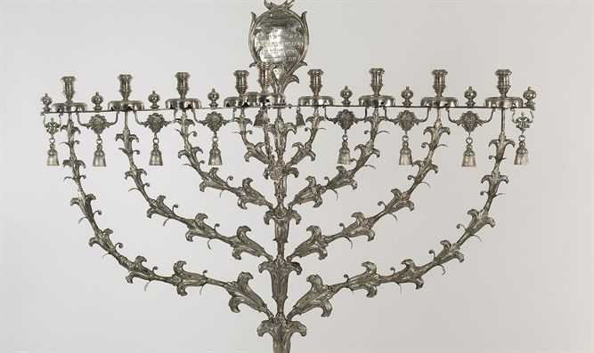
The Rintel Menorah on display at the Jewish Historical Museum of Amsterdam, Netherlands. Courtesy of the Jewish Cultural Quarter/JCK
For the Amsterdam Jewish Historical Museum, Hanukkah this year entailed the stressful chore of assembling the world’s most expensive menorah.
Last week, the Rintel Menorah, a 266-year-old menorah valued at over a half-million dollars, was put back on display at Amsterdam’s Jewish Historical Museum following the restoration of its wooden base, which was lost during the Holocaust. Built in 1753, the menorah is a relic from the golden age of a community that was nearly annihilated by the Nazis.
The restoration entailed the installation of a 3-foot wooden base created by the Judaica designer Piet Cohen. Before that, the Rintel stood on a rectangular marble slab that did little to complement the menorah’s intricate design, which includes eight bells and more than 150 delicate reliefs resembling flowers, leaves and thorns.

A Difficult Job in Transporting of the Menorah
The massive base had also complicated the annual transport of the menorah from the museum to the Rabbi Aron Schuster Synagogue, where the community would use it to light Hanukkah candles. Moving the menorah, a ritual that began in 1955 and was discontinued only in 2010, required a driver, three movers and a curator, who would dismantle the Rintel and pack its five parts into wooden boxes. The menorah would then stay at the synagogue, where it was somewhat vulnerable to theft, for a little over a week before the procedure would be repeated in reverse.
In 2016, the Rintel was appraised at $563,000. The price tag easily topped the list of the world’s most expensive Hanukkah menorahs that Israel’s Beit Hatfutsot Museum of the Jewish People had compiled shortly before.
The runners up were also Dutch: Twin menorahs, both much smaller and less ornate than the Rintel. One of the twins fetched $441,000 at an auction in 2016. The other is owned by the Dutch royal family and is on permanent loan to the Jewish museum.
The other menorahs have their charms, but the lighting of the Rintel “was a statement that said, ‘We’re still here,'” Ruben Vis, the chairman of the Organization of Jewish Communities in the Netherlands, or NIK, told the Jewish Telegraphic Agency.

Donated to the Great Synagogue of Amsterdam
The menorah was commissioned by philanthropist Sara Rintel from Pieter Robol II, a master silversmith, and donated it to the Great Synagogue of Amsterdam. Prior to that, Amsterdam’s Ashkenazi Jews had none of the flashy artifacts characteristic of the city’s older and more prosperous Portuguese communities, Vis noted.
“It was an attempt to match the Portuguese community’s splendor, and it marked a certain peak moment in Dutch Jewry’s history,” he said.
The Great Synagogue is among dozens of Jewish houses of worship in the Netherlands that did not survive World War II. Closed down in 1943 by the Germans, its furniture and marble were looted. Nearly all of its members were among the 75 percent of Dutch Jews killed by the Nazis, the highest death rate of any Nazi-occupied country in Western Europe. Some 40,000 Jews live in the Netherlands today, down from a prewar population of 140,000. The hall of the former synagogue is now part of the Jewish Historical Museum.

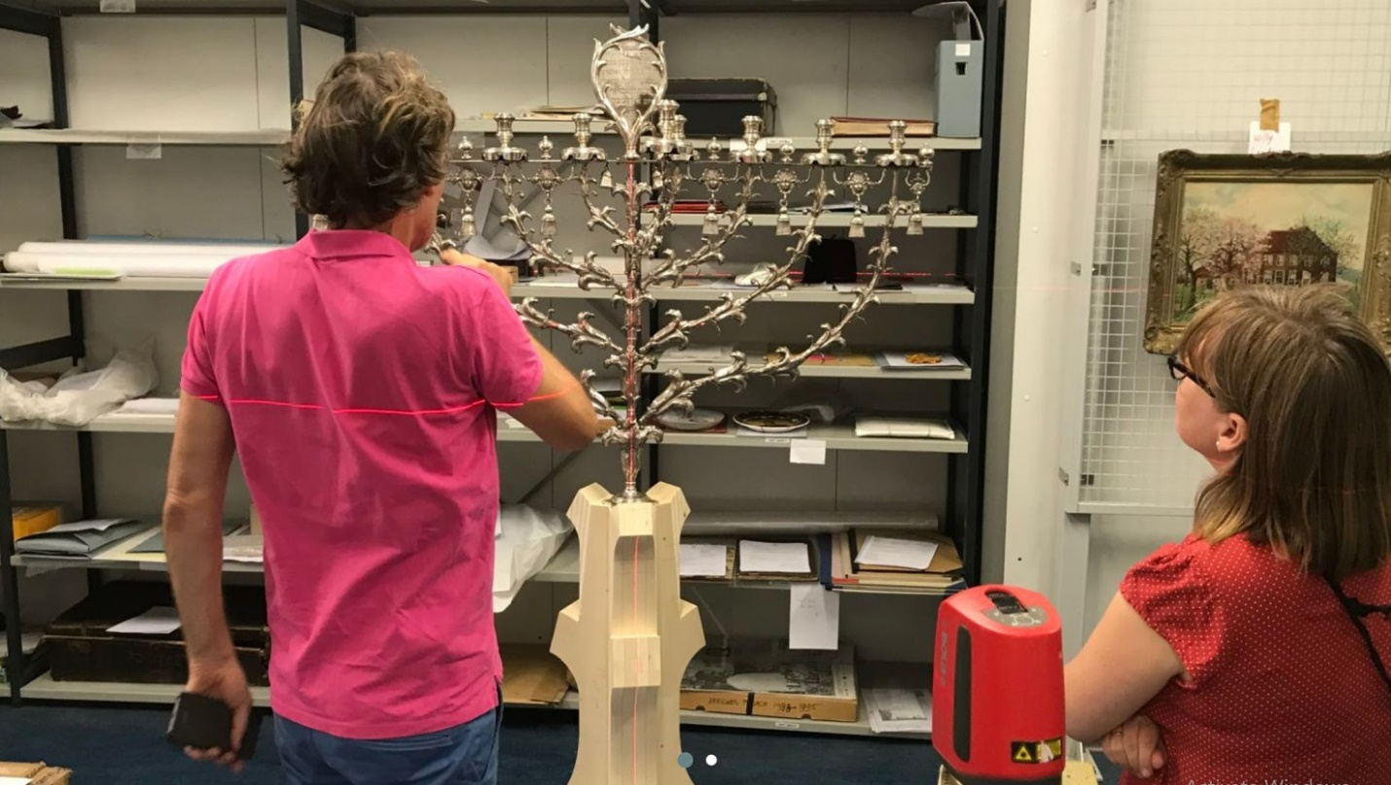
Restoration work and measurements being done on the Rintel Menorah in Amsterdam, the Netherlands in 2019. (Courtesy of Cambium Meubels)

Who exactly hid the Rintel during the war is unknown, but the disappearance of the wooden base suggests it may have been kept flat and concealed inside a piece of furniture.
The menorah is considered such a powerful symbol of Dutch Jewry that, in 1898, a replica was made for the Dritt Synagogue, another Ashkenazi house of worship that did not survive the war. The replica also survived the war and had for years been used for lighting candles at an annual Hanukkah concert at the Concert Gebouw, Amsterdam’s best-known concert hall.
In 2015, facing growing assimilation and rising security expenses, the Jewish Community of Amsterdam informed the Dutch government that it intended to auction off the original Rintel.
The community needed the government’s authorization for the sale because the Rintel was listed as a cultural heritage asset. But instead of approving the sale, the government, together with the Jewish Cultural Quarter and the Jewish Historical Museum, arranged to purchase the menorah and offer it on permanent loan to the museum.

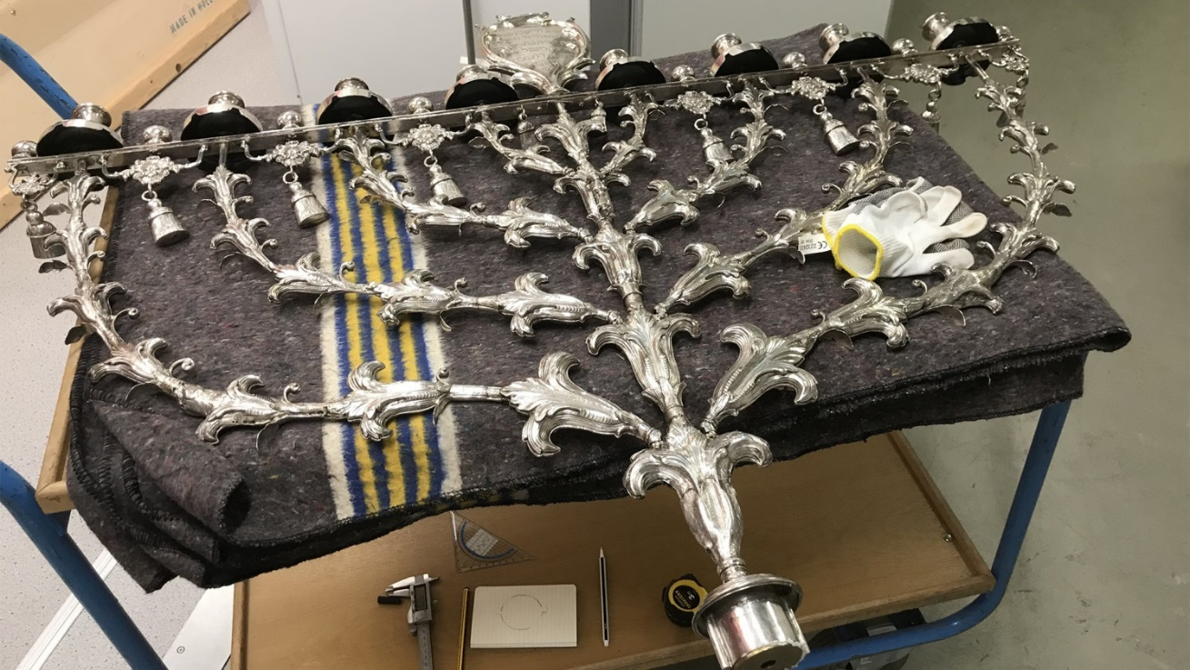
Restoration work being done on the Rintel Menorah in Amsterdam, the Netherlands in 2019. (Courtesy of Cambium Meubels)

According to Emile Schrijver, the director general of the Jewish Cultural Quarter, the umbrella group for five Jewish institutions located in the heart of what was once Amsterdam’s most heavily Jewish neighborhood, the Dutch government provided half of the $563,000. Another $125,000 came from the Rembrandt Association, a Dutch organization that helps raise money for the preservation of significant artworks. The rest came from various other donors. The sale was completed in 2016.

A Change in Ownership
The scheme ensured the Rintel remained in the Netherlands, but the change in ownership also meant its permanent retirement. With its changed status from a ritual item used by a living Jewish community into the prized possession of a major museum — with all the preservation-related restrictions that come with it — the menorah could no longer be used for the annual Hanukkah candle lighting. Vis said his community has come to terms with the Rintel’s retirement.
“Objects have a certain lifespan – something we understand all too well in our current society, with its throw-away culture,” he said. “The Rintel has just reached its usability limit. And it became something else: A work of art. A jewel.”

Reprinted from the December 27, 2019 dispatch of the JTA (Jewish Telegraphic Agency)
The Potato Menorah Lit in Memory of the Holocaust
By Arutz Sheva Staff

New Jersey Hatzalah paramedics of New Jersey come to aid of elderly woman whose family lights an extra Hanukkah candle in a potato.

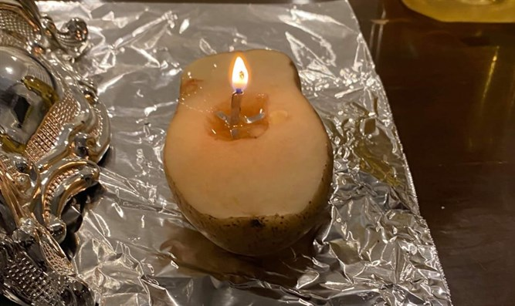
The potato menorah (photo by Sim Shain)

Hatzalah volunteers who came to the aid of an elderly woman in the city of Lakewood New Jersey Monday evening encountered an unusual sight on their way out of the home
Hatzalah paramedi Sim Shain described the memorable scene.
"Tonight I was on a Hatzolah call in Lakewood. As we wheeled the patient out of the house, we stopped with the stretcher for a minute for her husband to light the menorah".
"When we asked what that extra [potato] light was, he mentioned that in addition to lighting the menorah, he lights a wick in a potato to commemorate the menorah he used while hiding and running from the Nazis Yemach Shemom. We asked him to give a brocha to all of the Hatzolah members."

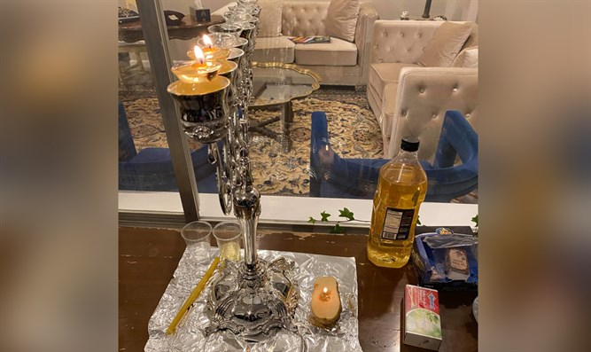
The potato near the 'regular' Hanukkah menorah

Reprinted from the December 25, 2019 email of Arutz Sheva.

Guinness World Records Certifies World’s Most Valuable Dreidel
By Marcy Oster

(JTA) — Jewelers in New York City have created the world’s most valuable dreidel, according to Guinness World Records.
The custom-designed piece created by Estate Diamond Jewelry is valued at $70,000. It includes the diamond-encrusted Hebrew letters nun, gimmel, hay and shin, and a 4.2-carat diamond on its tip.
The 18K gold dreidel stands 10.8 cm high. The letters are made of white gold and are encrusted with 222 round brilliant diamonds, according to Guinness. It was created in the artistic style of Art Deco, according to the jewelers, who said the final design was heavily inspired by the Chrysler Building located a few blocks from the company’s showroom.

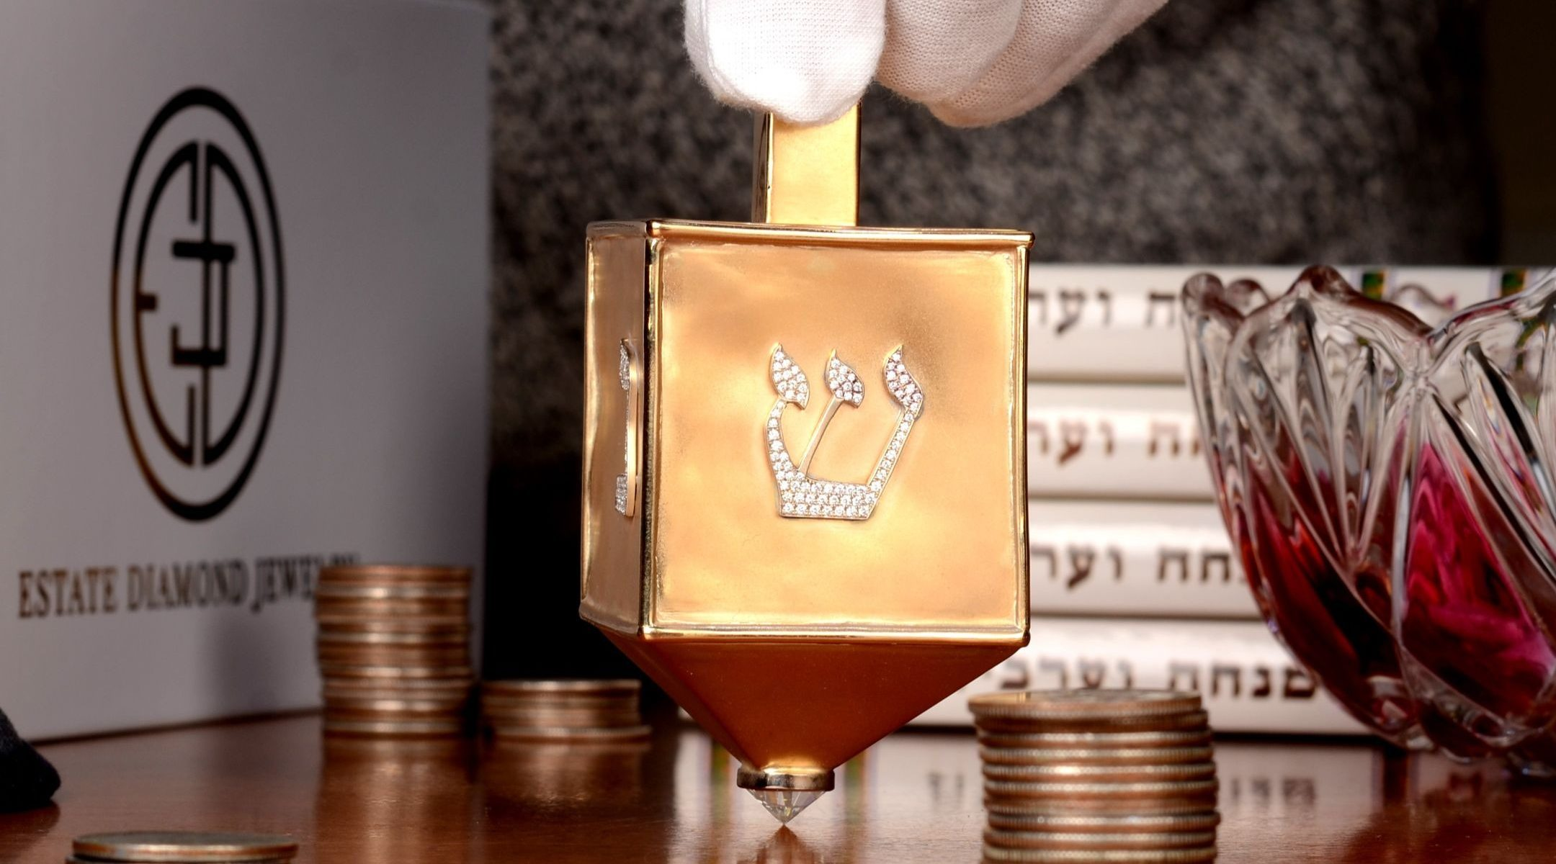
The $70,000 dreidel made of 18K yellow gold and encrusted with 220 round brilliant diamonds created by Estate Diamond Jewelry in New York City was named the world's most valuable dreidel by Guinness World Records. (Courtesy of Estate Diamond Jewelry)

Estate Diamond Jewelry has collected rare and vintage engagement rings for over 40 years.
“The inspiring message of Chanukah (aka Hanukkah) has always resonated with us and we love whimsical jewelry, so naturally, we have always tried to get our hands on an important antique dreidel to add to the collection,” the company said in a blog post.
“A few months ago, however, we decided that we wanted to create our dream-dreidel all by ourselves, inspired by the artistic designs of the vintage jewelry from our collection. We had no idea how fun this journey would be.”

Reprinted from the December 24, 2019 dispatch of the JTA (Jewish Telegraphic Agency)

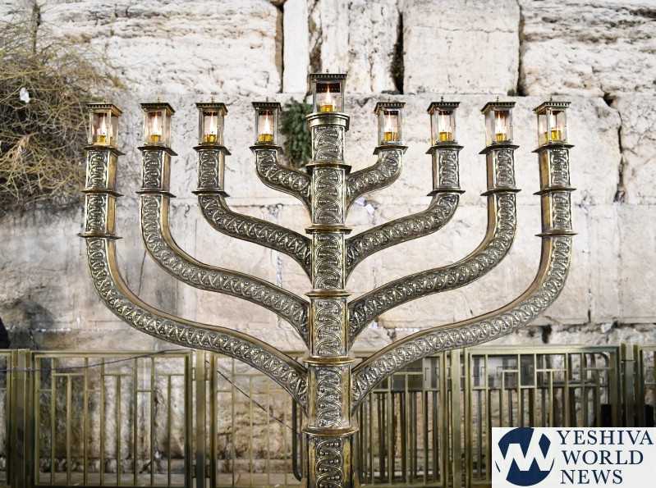
The Menorah placed in front of the Kosel (the Western Wall)

Reprinted from the Chanukah website of Yeshiva World News.

Hanukkah Photography Exhibit Offers a Window
Into Hasidic Jewish Life
By Curt Schleier

When the Yiddish New York Festival kicks off on the first night of Hanukkah, the coincidence of the weeklong celebration of Yiddish culture, food, music and dance with the Festival of Lights will be unmissable.
Aside from the traditional Hanukkah staples of latkes and jelly doughnuts that will be on hand, one highlight of the festival at the 14th Street Y in Manhattan will be the remarkable photography display called “Hanukkah in Mea Shearim (Jerusalem).”

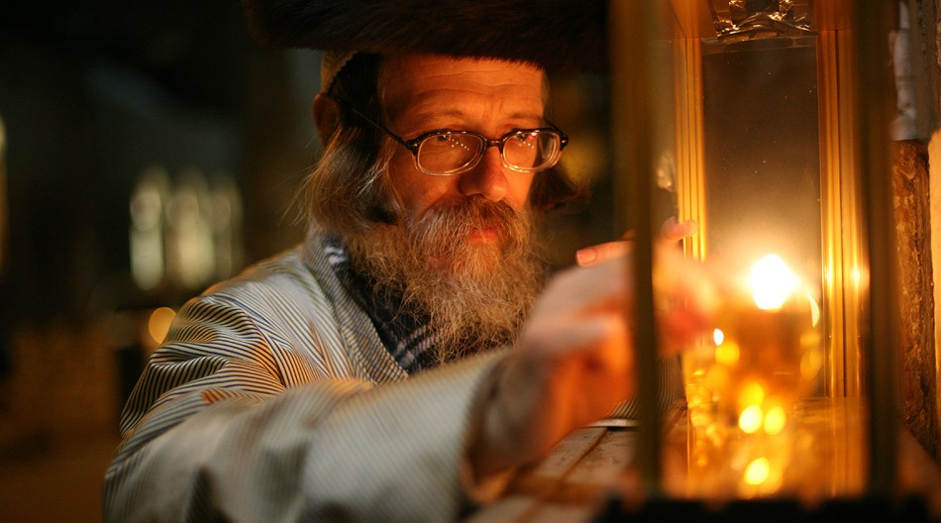
An exhibit of 11 photographs of Hasidim celebrating Hanukkah, all the work of Polish photographer Agnieszka Traczewska, will be on display at the 14th St. Y in Manhattan through late January. (Agnieszka Traczewska)

The photos in the exhibit offer a window into Hasidic life in the strictly Orthodox neighborhood of Jerusalem, offering an intimate glimpse of men, women and children celebrating the holiday. Behind this exhibit stands a most unlikely creator: Agnieszka Traczewska, a Catholic woman from Poland who has made photographing Hasidim part of her life’s work.
“People who see these photos see more than the physical Hasidim; they see their spirituality,” said Rabbi Michael Schudrich, the chief rabbi of Poland.
The exhibition of Traczewska’s work is just one of several planned in the United States in the coming months. Traczewska recently published a book of her photographs, “Returns,” and her next exhibit is scheduled for January in Palm Beach, Florida, to coincide with International Holocaust Remembrance Day.
These are the latest steps of a journey that Traczewska embarked upon 14 years ago: to remind people of the once-vibrant Jewish life in Poland, and to document visits by Hasidim to Jewish sites in Poland like cemeteries and old synagogues. Now she photographs Hasidim in communities around the world.
“We live in the 21st century, and these people seem to be frozen in time,” Traczewska said of her subjects. “But they are modern people living in the 21st century, using computers, cellphones and cars. Yet their tradition and faith is the most important aspect of their lives.”
Adrian Kubicki, director of the Polish Cultural Institute New York, said that Traczewska’s ability to gain the trust of her subjects and access to their normally insular community is a testament not just to her talents as a photographer, but to her interpersonal skills. The Polish Cultural Institute is the organizer of the exhibition in Manhattan, which will run from Dec. 22 through Jan. 20.

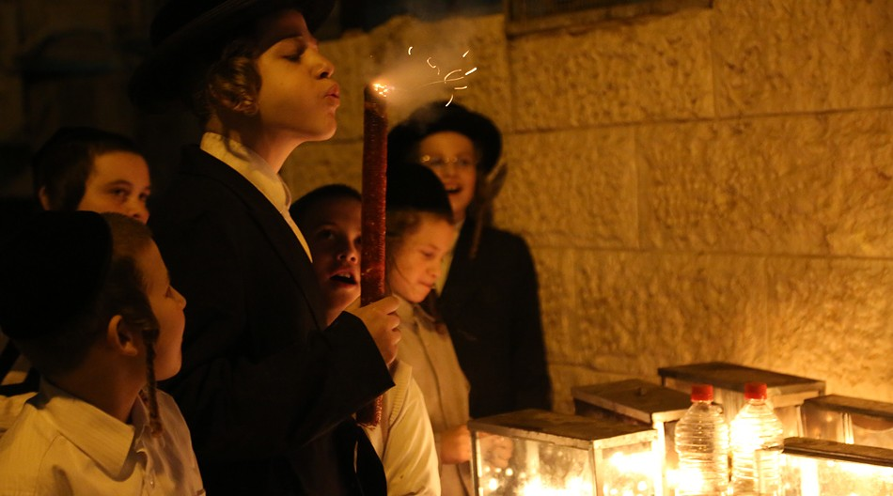
In the Mea Shearim neighborhood of Jerusalem, Hanukkah menorahs are commonly lit outdoors. (Agnieszka Traczewska)

“This is sort of a symbol, a bridge we build between Jews of Polish descent with their homeland,” Kubicki said. “It is to show how we appreciate their traditions and how Poland is involved in preserving this culture.”
Traczewska’s journey began when a nonreligious Jewish friend told her about an annual pilgrimage made by Hasidim from around the world to Lezajsk, Poland, to honor the yahrzeit (anniversary of the death) of Elimelech Weisblum, a renowned 18th-century Hasidic rebbe. The yahrzeit had become a pilgrimage day because Hasidim believe it marks an occasion when the soul of the deceased returns from heaven to earth and may answer the prayers of those gathered around his burial place.
The friend thought Traczewska might be interested in taking some photos. Traczewska recalled being shocked and entranced by what she witnessed.
“I’m very well educated. And I thought I knew Polish history. But Jewish-Polish history was erased. We were not taught anything about Hasidic traditions and other aspects of Jewish history,” she said. “It was as though these people were living in another world totally unknown to me. They looked like the photographs I saw from before the Second World War.”
The experience left an indelible mark on her.
“What was most impressive to me was how tied they were to their tradition, how they performed the same rituals that their fathers, grandfathers and even great-grandfathers performed,” Traczewska said.
Using her camera lens, Traczewska became determined to “excavate the Jewish history of my country.”
She began to learn more about Hasidic life, and to gently approach her subjects on their visits to Poland — often standing in the snow over the course of hours while Hasidim visited neglected cemeteries in the dead of winter. Her dedication did not go unnoticed, and gradually they opened up to her. Traczewska learned their rules, such as the strict separation of sexes in certain circumstances, and abided by them.
Over time, she says, the work became easier.
“Never easy. Just easier,” she said. “Every time they need to judge if they let me stay there.”
Like most Poles, Traczewska was born Catholic, but practiced her faith less and less as she grew older. Being exposed to the Hasids’ faith turned her “back to a religious path,” she said — not organized religion, but belief in a Higher Being.
Being a non-Jewish photographer of Hasidim has its advantages and disadvantages. On the one hand, she is an outsider and has had to work harder to gain her subjects’ trust. With her blond hair and Slavic face, it’s harder to remain unnoticed. But because she’s not Jewish, she says, Hasidim may be more open to her, and men give her more leeway in photographing in their spaces than they would if she were Jewish.
Traczewska now photographs Hasidim not just in her native Poland and in Israel, but in Hasidic communities throughout the world, including in Australia, England, Belgium and Brooklyn. Each time, she says, she has to win their trust and respect anew.
The 11 photographs on exhibit at the 14th Street Y are the fruit of work she began in 2014, when she started taking photos in Mea Shearim. Earlier this year, her works were exhibited at the United Nations building in New York.
“Somebody told me at one of my shows, ‘You are not just taking pictures. You’re telling stories,’” she said. “That captures what I’m trying to do.”

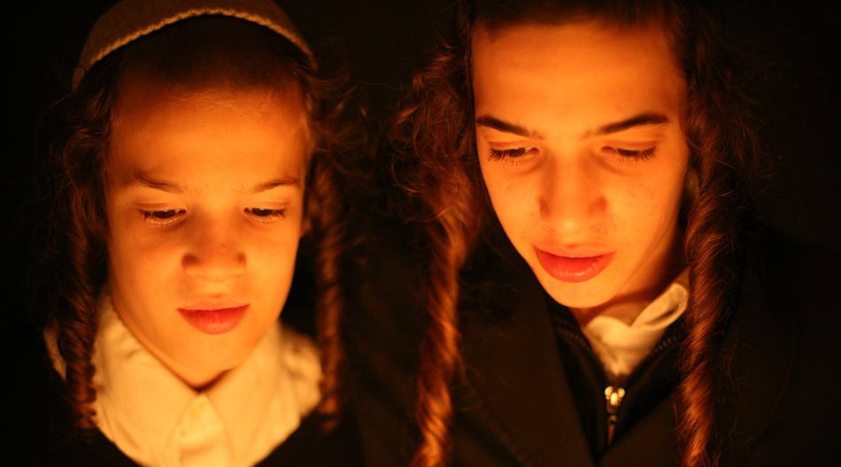
Hasidim from around the world, including these boys in Jerusalem, are the subjects of the work of Polish photographer Agnieszka Traczewska. (Agnieszka Traczewska)

This article was sponsored by and produced in partnership with the Polish Cultural Institute New York, a diplomatic mission of Poland’s Foreign Affairs Ministry that promotes comprehensive knowledge of Poland, Polish history and national heritage. This story was produced by JTA’s native content team.

Reprinted from the December 20, 2019 dispatch of the Jewish Telegraph Agency (JTA)

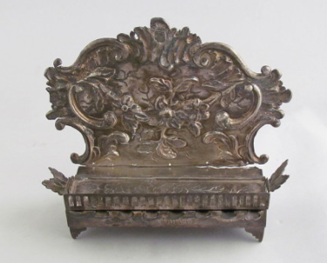

From the collection of the National Museum of American History
Rabbi Berel Wein
On Chanukah

As we know, it is our tradition to recite the Hallel service on all eight days of the festival of Chanuka. However, on the great festival day of Purim, a day which also celebrates the miraculous deliverance of the Jewish people from disaster and extinction, the Hallel service is omitted from prayers recited on that day.
The rabbis of the Talmud, commenting upon this difference between these two rabbinic holidays, explain that the holiday of Chanukah occurred on the basis of miracles that took place in the land of Israel, and, therefore, the recitation of Hallel is proper, while the miracle and salvation of the Jewish people which we commemorate on the day of Purim took place while the Jewish people already were in exile, and took place outside of the land of Israel.

A Distinction Between Two Sets of Facts
At first glance, this appears to be a technical and superficial distinction. It represents a distinction between two sets of facts but does not explain the fundamental difference between them. In fact, one would be tempted to say that the miracle of Purim, because it did in fact take place outside the land of Israel in a foreign and hostile environment, should be reckoned as the greater miracle, and should merit more strongly the requirement of reciting Hallel on the day of its commemoration. Over the ages, we have accepted this distinction between the two holidays, but for many, the true difference has eluded our understanding.
As you can well imagine, the issue has been thoroughly discussed over the ages by the great rabbinic scholars and commentators. This distinction is especially difficult for us to reconcile with our limited human logic. We see both the Mishnah and Talmud strongly emphasize the holiday of Purim, which has an entire tractate of the Talmud devoted to it, while the holiday of Chanukah appears to have relatively little discussion.

We Always Strive to Attain a Deeper Understanding of Special Days
It is not my purpose in this essay to discuss all the various ideas, insights, and comments that the great scholars of the Jewish people have opined on this subject over the ages. Suffice it to say, this matter has occupied much space, thought, and discussion. We can well understand why this would be the case, since we always strive to attain a deeper understanding and spiritual analysis of the special days in the Jewish calendar, and the lessons they come to teach us in each and every generation, in every situation and society.
It would be negligent on the part of all of us who celebrate these days not to have arrived at some sort of insight regarding the different modes of prayer on these different days and the miracles that the Lord performed for us.
My meager contribution to this subject, I think, has a certain validity in our time. Living in the land of Israel means living in a constant moment of miracles. Even though we become accustomed to what we call "normal life" in this country, we are reminded every so often by events that the mere presence of the Jewish people in our ancient homeland is an historical miracle almost unparalleled in the annals of human history.

We Become Accustomed to Miracles
As such, we become what the rabbis called “accustomed to miracles.” And, when a special miracle occurs, we would tend to ignore it, not recognize its validity, or not appreciate its import on all Jewish life for generations yet to come.
The miracle of Chanukah that took place in the land of Israel has to be emphasized in order that the people would appreciate how extraordinary this special miracle was, and how necessary its occurrence was to Jewish survival and growth. Many times, miracles may go unnoticed simply because of the atmosphere of the miraculous which permeates the land of Israel.
Outside of the land of Israel, human beings always deem life to be normal, regular, and predictable. Even though this is never actually the case, we tend to think in those terms when living in the Diaspora. Because of that mindset, we are certainly aware of every miracle that occurs, even if it is, so to speak, relatively minor and hidden.
In the Diaspora, there is no necessity for us to recite Hallel to appreciate that a miracle occurred. I think that this is the essential difference between life in the land of Israel and life outside of the land of Israel.

Reprinted from the website of Rabbiwein.com

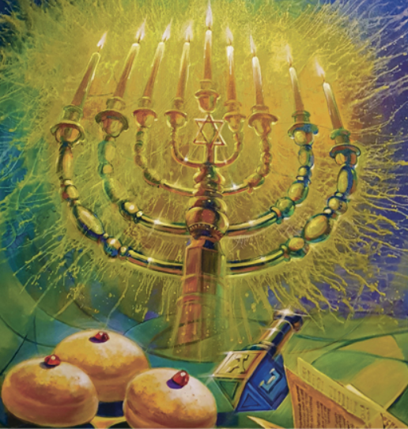
Painting by Alex Levin www.artlevincom

